MIDTOWNERS SUNSHINE OF THE WEEK ► August 17th, 2007
Birthday of Hyadi Sowerwine spouse of Rtn. David on August 19th

SPEAKER OF THE WEEK ► Ms. Trishna Gurung
THEME | Conservation in Nepal
Trishna Gurung, Communications and Marketing Manager, WWF Nepal has worked with WWF for over three years. Armed with a Master's Degree in Communications, Trishna's professional and personal interests intersect at a commitment to work with people to find solutions that will save a living planet. She enjoys Nepal, reading, writing, and the radio. She will give an introduction to the global conservation organization in Nepal and will shed light on the major threats and how we're addressing them.

UPCOMING SPEAKERS ► PREVIEW
DATE | SPEAKER | THEME
Aug 24th | Dr. Pramod B. Shrestha  Professor, IOE | Cambodia: Images of a country (Past, Present and Future)
Aug 31st | Om Prakash Yadav  Award winning Nature Photographer | Dos and Don’ts when taking photos
Sept 7th | H.E. the Malaysian Ambassador to Nepal | Dinner Meeting

THE MID-TOWN CLUB ► NEWS
Last Week’s Speaker

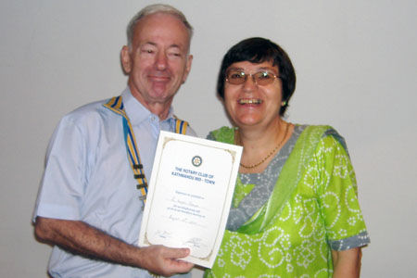
Guest Speaker Jo Logghe accepting letter of appreciation from President Walter

FLOOD RELIEF FUND
Through the initiative of Rtn. Govinda, our club has raised Rs. 34,100 for The Flood Disaster Relief Fund. In addition, CSD Pratap contributed 25 tarpaulins worth Rs. 25,000 as combined contribution of his company Nepal Tent and Tarpaulin and our club. The Nepal Rotary District has set up a committee to co-ordinate the donations from Nepal Rotary Clubs. The committee will hand over the collections to The Nepal Red Cross.
Those of you that still wish to make a donation, please contact Rtn. Govinda.
SIGHT PROJECT
With the aim to cover at least 100,000 school children nationwide by the World Sight Day on October 11th, a professional group led by PP Dr. Lekha are holding training forums for Rotaracts in the valley this month. The group plans to travel to Biratnagar and Chitwan to hold similar programs for Rotarians and Rotaracts. Our club members made individual donations of Rs. 17,000 to help buy spectacles for the children in need.
LELE VISIT
On Saturday, 11 August 2007 some of our members visited Lele VDC on the initiative of CSD Pratap Malla to assess the possibility of forming an RCC. IPP CK, PP Ambica, PP Gopal with spouse, PP Jyotsna with nephew, President Walter, Rtn. Werner, VP Navyo, VSD Saroj, Rtn. RR, CSD Pratap with spouse, Rtn. Manish and Jo Logghe, a new friend of our Club went over to the beautiful, but somewhat hidden valley of Lele, 16 km (4 km rough road) south of Patan at the edge of the valley. The President of the newly established RCC, Maj. (Retd) Raghunath Thapa showed the school premise and gave a very impressive and detailed overview on the Lele VDC, the schooling situation, and the socio-economic situation. The VDC comprises of 9 Wards (Wada) and consists of about 20,000 people of different ethnic backgrounds, mainly Newars, Chettris, Tamangs and Dalits. The economy in Lele VDC is obviously agro based and the schooling is relatively well organized until SLC level, but lacks a +2 level as there is no room for such classes. He explained in detail the ongoing work, mainly supported by the VDC and private support. Many people still lack the economical will or possibility to sustain girls for schooling, and our contribution in this regard is highly appreciated. VSD Pratap announced that the schoolbags for the students are contributed by his company, so that we could reach the number of 20 students. All students were selected based on the socio-economic needs so it is ensured they all come from lower social strata and deserve to be supported by us. Thereafter the scholarships where handed over to 20 girls which we sponsor with the help of the Rotary Club of Milano-Villoresi (Dist. 2040 Italy).

After the hand-over ceremony, the RCC had also organized a tree planting where all Rotarians participated. At end the day, the group visited the proposed basketball court, which is awaiting sponsorship. The VDC and RCC of Lele invited all the present Rotarians and their friends to a sumptuous Dal Bhat meal. In his final remarks, President Walter commended the surprisingly well and efficiently organized event and assured those present that with due course of time, our Club will deepen and strengthen our collaboration, and thanked the headmaster and the RCC for the organization. Kudos to CSD Pratap for the overall organization and the great time and fellowship that was in true spirit of Rotary.

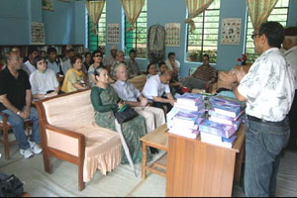  Club members listening intently | 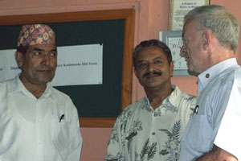  President Walter and CSD Pratap with Mr. Raghunath Thapa |  | 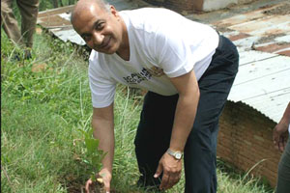  IPP CK planting tree sapling
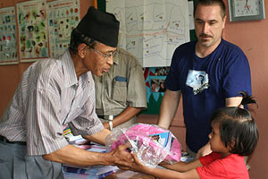  Rtn. RR handing out goodies to a girl |  | 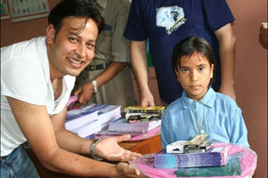  Rtn. Manish presenting education materials

Editor: Rabi Karmacharya, Club Service Director email: rabikarma@gmailcom

